**SOCIAL MEDIA MARKETING**

**Batch-10**

**Submitted By : Laiba Asif**

**Submitted to : Qasim Nadeem**

**Date: 19-9-24**

**Table of Content**

1. **Product Selection**
2. **Brand Identity Development**
3. **Target Audience Identification**
4. **Content Strategy Creation**
5. **Engagement Strategy**
6. **Ad Campaign Development**
7. **Campaign Execution**

**Product:** I choose virtual services (digital marketing services) to offer by creating marketing agency.

**Page Name: BRANDIFY (Digital Marketing Agency)**

1. **Brand Logo**

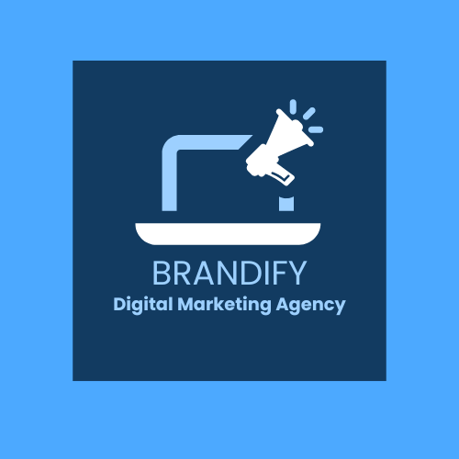

1. **Brand Tagline**

**“Where technology meets creativity”**

1. **Brand Cover photo**

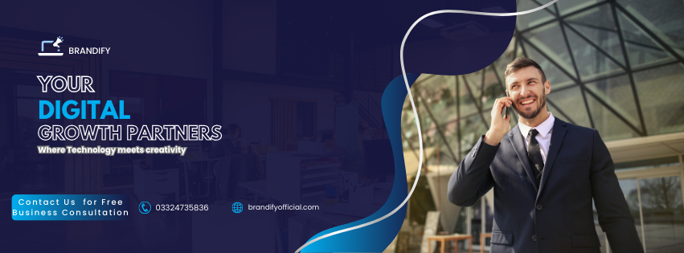

1. **Page Link**

<https://www.facebook.com/brandify23>

1. **Audience**

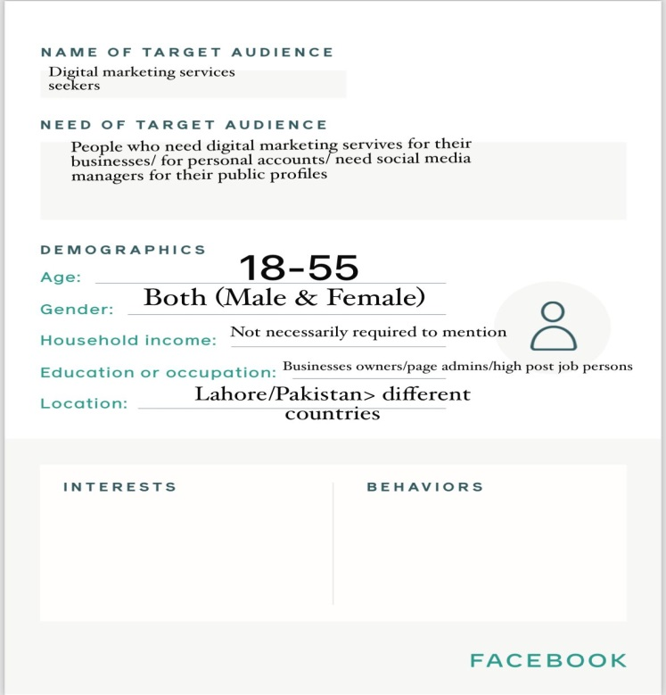

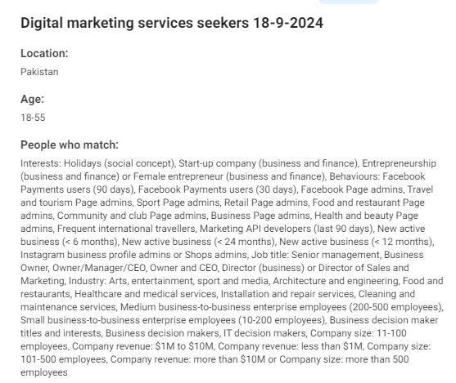

**Content Strategy For Seven Days**

**Post 1: In ad creative tell shortly about “Brandify”**

**AD COPY: "Brandify,** Your digital compass, guiding you through the ever-evolving landscape of marketing. We're here to make your brand unforgettable."

**Caption:** "Introducing Brandify! Your digital compass.

**Hashtags**: #digitalmarketingagency #digitalmarketing #socialmediamarketing #digitalmarketingservicescompany #digitalmarketingstrategy #onlinemarketing #SociaMediaMarketing #digitalmarketingservices#entrepreneur #ContentMarketing #marketingstrategy #brandify#digitalmarketingwitbrandify #digitalmarketingtips #digitalmarketingmeme #GoogleAdsense

**Post 2: Tell about digital marketing services that “Brandify” offer**

**AD Copy: Mention services that “BRANDIFY” provide:**

1. **Online Brand Building**
2. **Social Media Marketing (Facebook, Instagram, Tiktok, LinkedIn)**
3. **Content Writing**
4. **Google Ads (ppc, youtube ads, email-marketing, sales ads)**

**Caption: Maximize your online presence.** Let's work together to grow your business.

**Hashtag:** : #digitalmarketingagency #digitalmarketing #socialmediamarketing #digitalmarketingservicescompany #digitalmarketingstrategy #onlinemarketing #SociaMediaMarketing #digitalmarketingservices#entrepreneur #ContentMarketing #marketingstrategy #brandify#digitalmarketingwitbrandify #digitalmarketingtips #digitalmarketingmeme #GoogleAdsense

**Post 3: Importance of social media marketing**

**AD COPY: In ad creative tell importance of social media marketing through design a post with text “**Social media marketing has a 122% higher conversion rate than traditional marketing.”

**Caption: "**Ready to take your social media game to the next level? Let's talk. 💬"

**Hashtag:** : #digitalmarketingagency #digitalmarketing #socialmediamarketing #digitalmarketingservicescompany #digitalmarketingstrategy #onlinemarketing #SociaMediaMarketing #digitalmarketingservices#entrepreneur #ContentMarketing #marketingstrategy #brandify#digitalmarketingwitbrandify #digitalmarketingtips #digitalmarketingmeme #GoogleAdsense

**Post 4: Design a post in which you burst a myth related to content marketing**

**AD COPY: "Myth:** Content marketing is all about writing blogs**.**

**Reality**: Content marketing encompasses a wide range of formats, including videos, infographics, podcasts, and more. The goal is to create valuable and shareable content that attracts and engages your target audience."

**Caption: "**Did you know that content marketing isn't just about words? 💡 Discover the power of visual and audio content."

**Hashtag:** : #digitalmarketingagency #digitalmarketing #socialmediamarketing #digitalmarketingservicescompany #digitalmarketingstrategy #onlinemarketing #SociaMediaMarketing #digitalmarketingservices#entrepreneur #ContentMarketing #marketingstrategy #brandify#digitalmarketingwitbrandify #digitalmarketingtips #digitalmarketingmeme #GoogleAdsense

**Post 5: Design a post a in which offer a 7 day free trial of any digital marketing services**

**AD COPY:** Not sure if our services are right for you? Give them a test drive. “Try before you buy! 🆓 7-day free trial of our digital marketing services."

**“Add sticker of limited time offer”** in ad copy.

**Caption:** "Ready to take your business to the next level? Sign up for a free trial today. 🔗"

**Hashtag:**  #digitalmarketingagency #digitalmarketing #socialmediamarketing #digitalmarketingservicescompany #digitalmarketingstrategy #onlinemarketing #SociaMediaMarketing #digitalmarketingservices#entrepreneur #ContentMarketing #marketingstrategy #brandify#digitalmarketingwitbrandify #digitalmarketingtips #digitalmarketingmeme #GoogleAdsense

**Post 6: Design a post in which “Brandify” urge its audience for ‘free Business consultation”**

**AD COPY: "Need a digital boost?** Our team of experts can help you reach your target audience and achieve your marketing goals. From SEO to social media, we've got you covered."

**Add sticker “Free Business Consultation”**

**Caption: Level up** your online game. 🎮 Our digital marketing expertise can help.

**Hashtag:** : #digitalmarketingagency #digitalmarketing #socialmediamarketing #digitalmarketingservicescompany #digitalmarketingstrategy #onlinemarketing #SociaMediaMarketing #digitalmarketingservices#entrepreneur #ContentMarketing #marketingstrategy #brandify#digitalmarketingwitbrandify #digitalmarketingtips #digitalmarketingmeme #GoogleAdsense

**Post 7: Share a funny post**

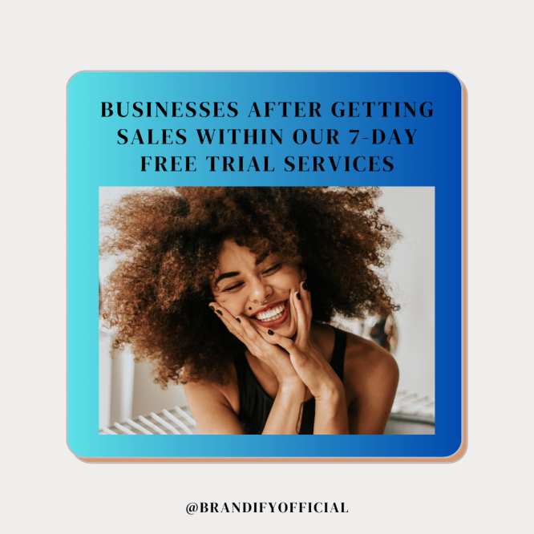

**Caption:** Try our digital marketing services for free for 7 days and see the difference.

**Hashtags :** : #digitalmarketingagency #digitalmarketing #socialmediamarketing #digitalmarketingservicescompany #digitalmarketingstrategy #onlinemarketing #SociaMediaMarketing #digitalmarketingservices#entrepreneur #ContentMarketing #marketingstrategy #brandify#digitalmarketingwitbrandify #digitalmarketingtips #digitalmarketingmeme #GoogleAdsense

**Story Content Strategies for 1 Week**

**Day1: Design a story with text Why It is necessary to bring business online?** In today's digital age, having an online presence is no longer a luxury but a necessity for businesses of all sizes.

1. Increased Visibility and Reach:
2. 24/7 Accessibility:
3. Data-Driven Insights
4. Enhanced Customer Experience

**Day 2: Addressing Common Misconceptions About Digital Marketing**

**Story1. Digital Marketing is Only for Large Businesses:**

* **False:** Digital marketing is accessible to businesses of all sizes. Even small businesses can benefit from effective digital strategies.

**Story2. Social Media is Just for Fun:**

* **False:** Social media can be a powerful tool for building brand awareness, engaging with customers, and driving sales.

**Story3. Digital Marketing is Expensive:**

* **False:** While some digital marketing tactics can be costly, there are many free or affordable options available, such as content marketing, social media marketing, and email marketing.

**Story4. More Followers Equals More Success:**

* **False:** The quality of your followers is more important than the quantity. Focus on engaging with a targeted audience that is interested in your products or services.

**Story5. Digital Marketing is a Quick Fix:**

* **False:** Building a successful online presence takes time and effort. It's important to have realistic expectations and be patient.

**Story6. Digital Marketing is a Replacement for Traditional Marketing:**

* **False:** Digital marketing should complement traditional marketing efforts. A well-rounded approach can yield the best results.

**Story7. All Digital Marketing Channels Are Created Equal:**

* **False:** Different channels have different strengths and weaknesses. It's essential to choose the channels that align best with your target audience and goals.

**Story8. Digital Marketing is Only About Technology:**

* **False:** While technology plays a significant role in digital marketing, it's ultimately about understanding your audience and creating meaningful connections.

**Day3“Share some interesting facts about advertising”**

**Story1: The first banner ad appeared in 1994.** It was for AT&T and appeared on a website called HotWired.

* **Story2: The term "blog" was coined in 1999.** It's a shortened version of "weblog."
* **Story3:** **The first tweet was sent in 2006.** It was sent by Jack Dorsey, the co-founder of Twitter.
* **Story4: The average person spends over 6 hours per day online.** That's a lot of time for businesses to reach potential customers.
* **Story5: Email marketing has a higher ROI than any other form of digital marketing.** For every $1 spent on email marketing, businesses can expect to earn an average of $42 in return.
* **Story6: Video content is more likely to be shared than any other type of content.** Videos can be a powerful tool for engaging your audience.
* **Story7: The most popular social media platform in the world is Facebook.** It has over 2.9 billion monthly active users.
* **Story8: The first chatbot was created in the 1960s.** It was named ELIZA.
* **Story9: The average person uses 10 different devices to access the internet.** This means businesses need to make sure their websites are optimized for a variety of devices.

**Day4: Asked some questions (with poll) in stories to audience**

**Story1. What is your biggest digital marketing challenge?**

* A. Generating leads
* B. Increasing website traffic
* C. Improving brand awareness
* D. Creating engaging content
* E. Managing social media

**Story2. Which social media platform do you use most frequently?**

* A. Facebook
* B. Instagram
* C. TikTok
* D. LinkedIn
* E. Twitter

**Story3. How do you prefer to receive marketing communications?**

* A. Email
* B. Social media
* C. SMS
* D. Website notifications
* E. Direct mail

**Story4. What is your primary goal when visiting a website?**

* A. Find information
* B. Make a purchase
* C. Contact the business
* D. Learn about the company
* E. Entertainment

**Story5. How do you feel about personalized marketing?**

* A. Positive
* B. Neutral
* C. Negative
* D. Unsure

**Story6. What factors influence your decision to purchase a product or service online?**

* A. Price
* B. Reviews
* C. Product descriptions
* D. Shipping options
* E. Return policy

**Story7. How important is customer service to you when making a purchase online?**

* A. Very important
* B. Somewhat important
* C. Not very important
* D. Not at all important

**Story8. What is your biggest concern about online shopping?**

* A. Security
* B. Privacy
* C. Product quality
* D. Shipping delays
* E. Returns

**Story9. Have you ever used a chatbot for customer service?**

* A. Yes
* B. No
* C. Not sure

**Story10. What do you value most in a digital marketing agency?**

* A. Expertise
* B. Results
* C. Communication
* D. Creativity
* E. Affordability

**Day5: Design funny meme for stories**

**Story1:** **Overwhelmed by analytics:** A person drowning in a sea of data, with captions like "Trying to make sense of Google Analytics.

**Story2:** • **The SEO guy:** A detective investigating keywords, with captions like "SEO detective on the case."

**Story3:** **The social media manager:** A superhero saving the day on social media, with captions like "Your social media superhero is here."

**Day6: Share information through stories Why to hire a “Brandify” (digital marketing agency) for your Business**

**Story1. Expertise and Specialized Skills:**

* **We have** team of experts who are well-versed in various digital marketing strategies, techniques, and platforms.
* **Staying up-to-date:** We are keep up with the latest trends and best practices in the industry, ensuring your business benefits from the most effective approaches.

**Story2. Time and Resource Efficiency:**

* **Outsourcing tasks:** By hiring Brandify, businesses can free up their internal resources to focus on core competencies.
* **Streamlined processes:** Brandify have established processes and tools that can help streamline marketing efforts and improve efficiency.

**Story3. Measurable Results:**

* **Data-driven approach:** Brandify use analytics and tracking tools to measure the effectiveness of campaigns and make data-driven decisions.
* **ROI tracking:** Brandify can help you track your return on investment (ROI) and optimize your marketing efforts accordingly.

**Story4. Access to Advanced Tools and Technology:**

* **Specialized tools:** Brandify have access to a wide range of specialized tools and software that can enhance their marketing campaigns.
* **Cost-effective access:** These tools can be expensive for individual businesses, but Brandify can provide access at a more affordable rate.

**Story5. Fresh Perspectives and Creativity:**

* **New ideas:** Brandify can bring fresh ideas and creative solutions to your marketing efforts.
* **Strategic thinking:** Brandify can help you develop a comprehensive marketing strategy that aligns with your business goals.

**Story6. Scalability and Flexibility:**

* **Adapting to changing needs:** Brandify can quickly scale their services up or down to meet your evolving needs.
* **Handling peak periods:** Brandify can provide additional support during peak seasons or promotional campaigns.

**Story7. Cost-Effective:**

* **Specialized expertise:** Brandify can provide services at a lower cost than hiring in-house experts.
* **Scalability:** You only pay for the services you need, avoiding unnecessary overhead costs.

**Story8. Accountability:**

* **Clear goals:** Brandify accountable for achieving specific marketing goals.
* **Performance tracking:** Brandify can provide regular reports on campaign performance and make recommendations for improvements.

**Story9. Focus on Core Business:**

* **Free up resources:** By outsourcing brandify for any servicve, you can focus on your core business operations.
* **Increased efficiency:** This can lead to improved productivity and overall business performance.

**Day 7:**

**Story 1;** Design a story with text **“Contact Us for Free Online Business** Consultation”

**Story2: Design a story with “ Avail Our Amazing Offer 7-Day Free Trial of Any Service”**

**Engagement Strategies to grow my Page & Build Audience**

**Time:** Start publishing campaign after First Week with posting start regularly for 1 Week

1. Run **Page Likes campaign** for facebook page with a creative text (Social media marketing has a 100% higher lead-to-close rate than outbound marketing.) with targeting all business owners/high post job persons/small business owners/enterpenuers/Page admins

**A/B Testing**

1. **Run Page visit campaign** for instagram +Facebook page with a creative “Free Online Business Consultation” targeting all businesss onwers+ page admins

**OR**

1. **Run whatsapp message campaign on fb+insta with creative** “Free Online Business Consultation”, targeting all small business owners/ page admins/ medium scale business owners/enterpenuer/without specify any audience

**Or**

1. **Run whatsapp/insta message campaign** on fb+insta (automatic placements) with a creative “ Sign Up For 7 Day Free Trial of Any Digital Marketing Service” or “Gain results with Our Digital Marketing Services for Free” targeting to all business owners/Page admins/small businesses/medium employment/enterpenuers/Digital marketing services seekers/without specify any audience/advantage setting

**3rd Week:**

1. **Post a Giveway,** mention rules to participate in giveway (like, share this post, mention three business owners/business page admins in comment section that must follow our page, share this post on your story until the winner announce.
2. **Engage with any creator/** influencers that make content related to marketing & charge less, he/she will tell to their audience about your agency & services plus 7 day free trial services offer.
3. **Engage with any blogging site/online** magazine(charge less) that post about your agency & services

**4th Week**

1. Start running lead campaign(whatsapp messages) with a creative “ You Need Digital Marketing Services for Free”, targeting all predefined audience

**OR**

1. Lead campaign with creative “You Need Digital Marketing Services for Free” then land to lead form with questions
   * 1. Which service you need for free (a. brand building, social media marketing, content writing, Google ads,)
     2. Tell about the nature of business (___)
     3. Contact number + name

**5th Week**

* + - 1. **Run vedio ad(lead campaign) in which person/page owner tell about brandify 7 days Free services offer > then land to whatsapp messages** targeting to all business owners/Page admins/small businesses/medium employment/enterpenuers/Digital marketing services seekers/without specify any audience/advantage setting

**Campaign Execution**

**Fb Page Like Campaign**

**Step1:**

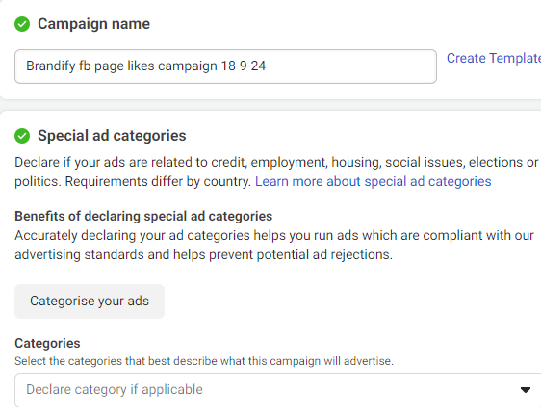

**Step2:**

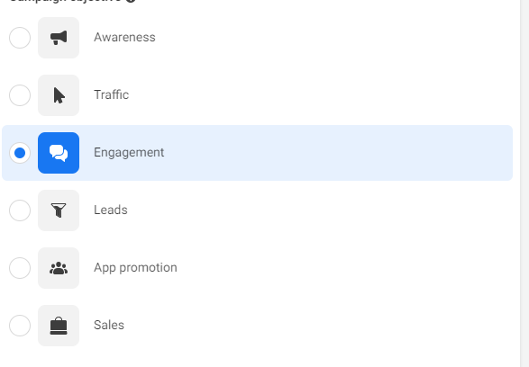

**Step3:**

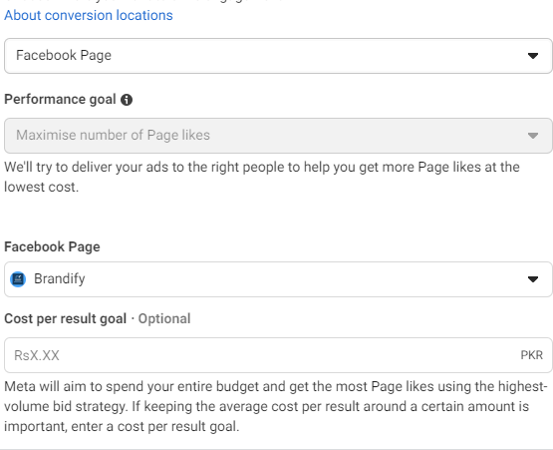

**Step 4:**

**AD GROUP 1: ( ad groups differ on the basis of audience selection & placements )**



**AD GROUP2:**

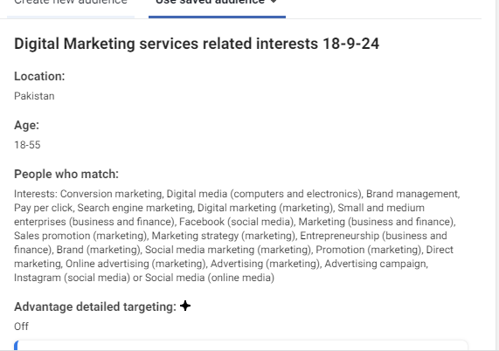

**AD GROUP 3:** 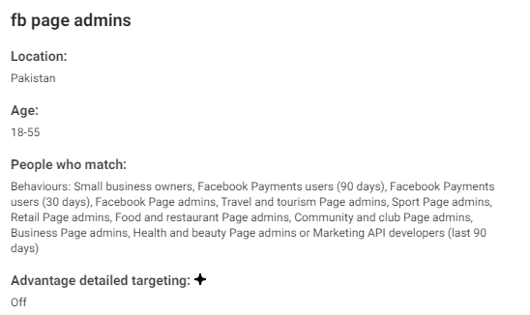

**AD GROUP 4:**

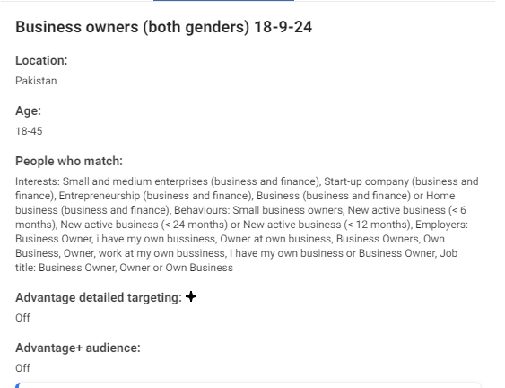

**AD GROUP 5:**



**AD GROUP 6:**

**(Without specify any audience)**

**Step 5:**

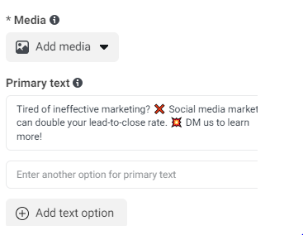

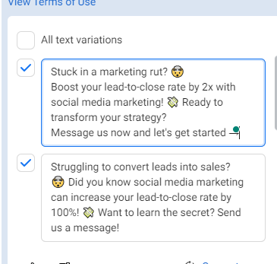

**\*\*Creative text (Social media marketing has a 100% higher lead-to-close rate than outbound marketing.)**

**LEADS CAMPAIGN**

**Step1:**

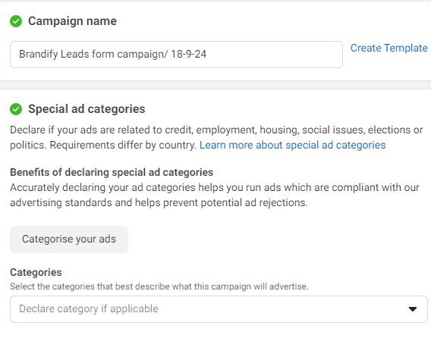

**Step2:**

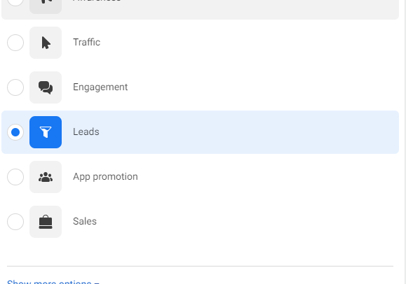

**Step3:**

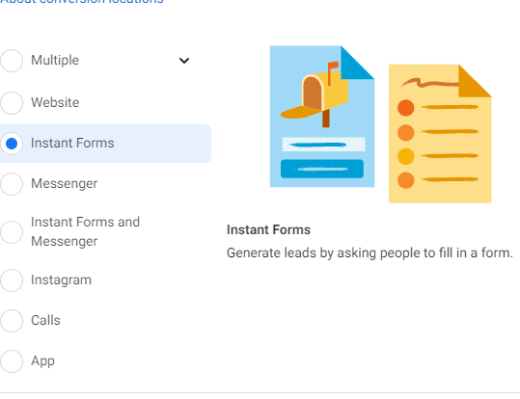

**AUDIENCE : SAME AS USED IN LIKES CAMPAIGN PLUS use BUSINESS OWNERS audience in different ad bgroup to check whether it will perform or not**



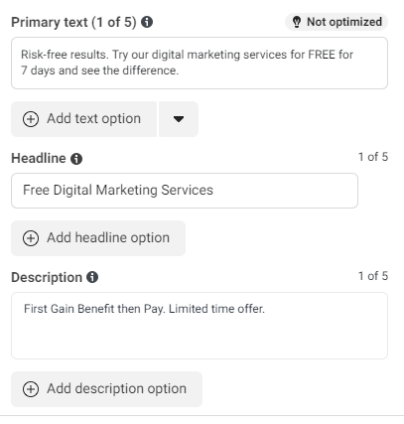

**Creative “You Need Digital Marketing Services for Free”**

**Lead Form**

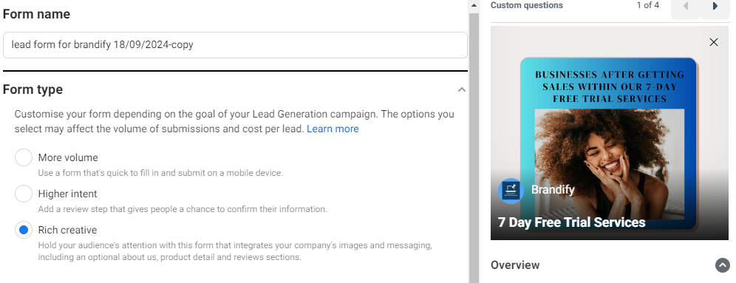

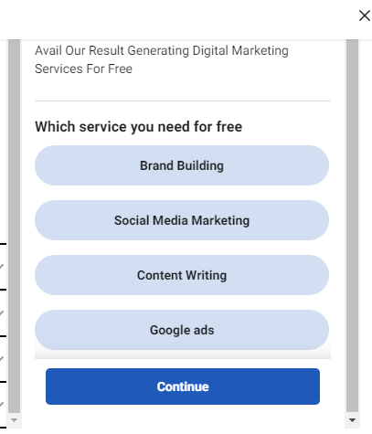

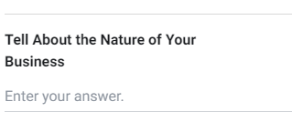

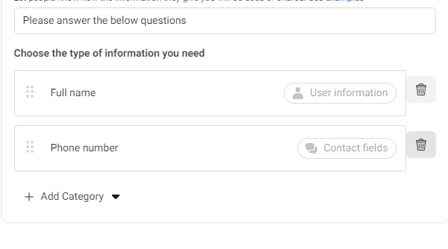

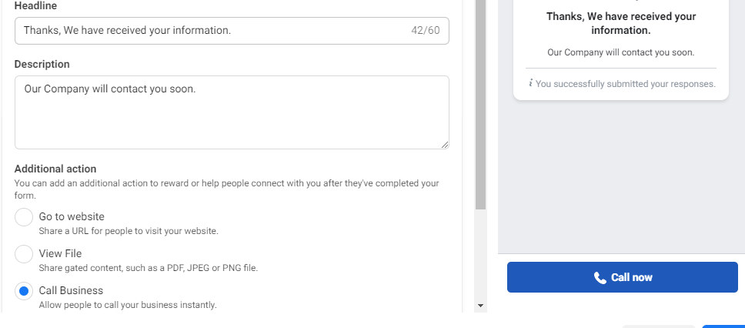

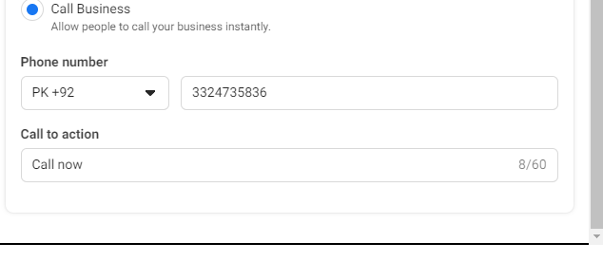

**\*\*AD SETS DIFFER ON THE BASIS OF AUDIENCE PLUS PLACEMENTS (TRY ALL DIFFERENT OPTIONS IN INITIAL CAMPAIGNS TO FIND OUT BEST RESULT PRODUCING AD SETS + STRATEGIES).**

**Campaign Evaluation: It can be done after publishing campaigns, major KPI’s are cost per like, per lead cost, per 1000 impression cost (in awareness campaign. ROI is important in case of sales campaign.**